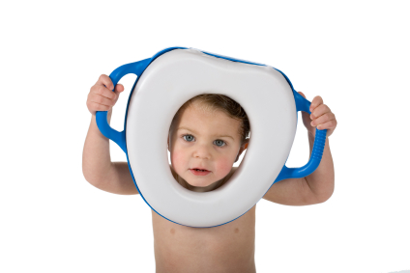
Toilet Training – is my child ready?

At Wakoos we are here to support your child and family during all the stages of their development.

Toilet training can be a daunting task for all involved but by recognising when your child is ready and following their lead it can be a simple, enjoyable process.

The first thing to work out is why you are thinking about toilet training. Is it because your child has reached a certain age? Are all your friends children doing it and you feel like yours should be too? There is no right or wrong age to start toilet training but it is crucially important to ensure that your child is ready before you begin. Children do not need to be toilet trained before moving to pre-school!!

There are a number of signs that your child is starting to develop bladder control:
- they know when they've got a wet or dirty nappy
- they get to know when they're passing urine and may tell you they're doing it
- the gap between wetting is at least an hour (if it's less, toilet training may fail, and at the very least will be extremely hard work for you)
- they show they need to pee by fidgeting or going somewhere quiet or hidden
- they know when they need to pee and may say so in advance
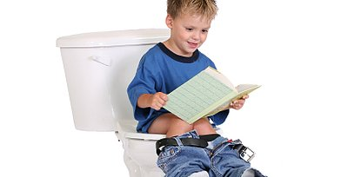
Toilet training is usually fastest if your child is at the last stage before you start the training. If you start earlier, be prepared for a lot of accidents as your child learns.
They also need to be able to sit on the potty or use a step to sit on the toilet and get up from it when they’re done. They should be able to follow your instructions and be able to help with dressing and undressing.

If you think your child is ready to begin this exciting new stage of development then please speak to a member of the team so we can work together for the best outcomes. It is common for children to have more frequent accidents at nursery as they are distracted and engrossed in exciting play opportunities however if your child is truly ready for toilet training then this stage will quickly pass.

